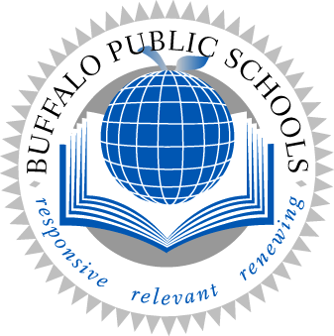
The Frederick Law Olmsted School

At Kensington
319 Suffolk Street

Buffalo, New York 14215

Phone (716) 816-4330
Fax (716) 838-7530

Michael Gruber Ed.D., Principal James Fredo, Assistant Principal
Catherine Dulak, Assistant Principal Leslie Potempa, Assistant Principal

July 22, 2019

Dear Parents and Guardians,

The Buffalo Public School District is hosting a Freshman Orientation for incoming ninth grade students. Your child is expected to attend the Freshman Orientation at Frederick Law Olmsted School #156.

This year’s program is a 2 day program that will occur on August 6th and August 7th from 8:30 a.m. until 11:30 a.m. It is for students only. The Freshman Orientation will give your child an opportunity to meet their counselors and administrators, as well as a chance to tour our school building and address transportation procedures. Furthermore, the academic component will address the rigor of high school by focusing on literacy in the core areas, and include a presentation on the school’s website, a review of our grading system, and study skills. We will also present an overview of the state and schools’ graduation requirements. Our SAY YES facilitator will give a short presentation to discuss what her program has to offer students and families. We hope that your child will be able to attend!

We look forward to meeting your child at the Freshman Orientation and working to support his or her academic endeavors over the next four years. Please call 816-4330 between the hours of 8am and 2:30pm to let us know if your child will be attending. Transportation will not be provided by the district. Breakfast will be provided. If you have additional questions, feel free to contact me at any time.

Thank you and have a great day!

Sincerely,

Leslie Potempa
Assistant Principal

