What is Schoology?
Schoology is the Learning Management System (LMS) for the Buffalo Public Schools. Teachers use Schoology to post classroom materials online; provide a safe forum for students to discuss their ideas and collaborate on projects; and to assign and collect assignments electronically. It helps students stay organized and keeps the class connected.

What are Schoology Parent Accounts?
A Schoology Parent Account gives you access to the classes your child(ren) are enrolled in, your child(ren)’s upcoming assignments, messaging features, and any feedback your child(ren) receives on digital assignments, tests, quizzes and projects.
*(To check official gradebook, please use Infinite Campus Parent Portal
Having a Parent account in Schoology is like having two accounts:
- Your personal account, with your own name and information
- Your Child(ren)’s Activity where you can view Schoology from your child’s perspective to see what your child sees and receive updates about his or her activity.

How Do I Find My Schoology Log In Information?

From Parent Portal  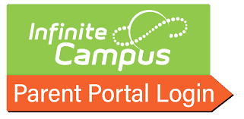  - Log in to your Parent Portal account.  If you don’t have a Parent Portal account, click here to request access.  - Click More at the bottom of the landing page.  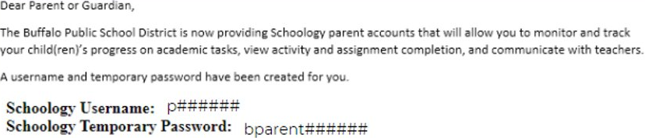  - Click Schoology Parent Portal to retrieve your log in information. | Or | From My Child(ren)’s School  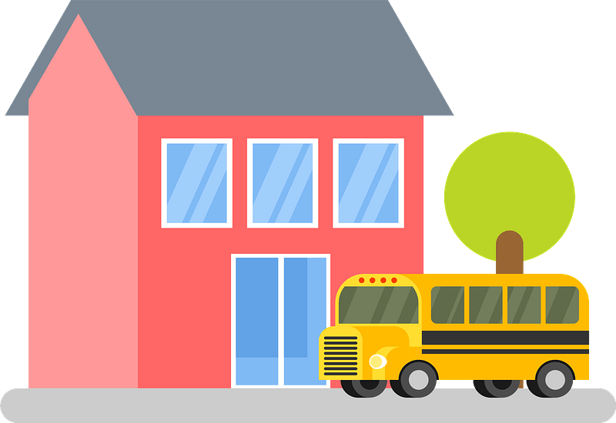  If you don’t have a Parent Portal account, please contact your child(ren)’s school and ask for your Schoology Parent Account log in information.

How Do I Log In to My Schoology Parent Account?
Visit www.apps.schoology.com | 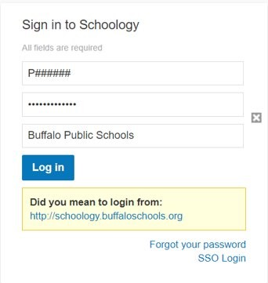  Log in using your username and temporary password. If you can’t find Buffalo Public Schools, begin typing 14202 in the search bar.  Once logged in, don’t forget to change your password and update your email address.

