Frederick Law Olmsted #156
Re-Opening Parent Forum
January 14, 2021
Questions & Answers

COVID-19
How will a positive test result for a student that is in the building, affect other students in the classroom? If a student tests positive for COVID, would the rest of the students and teacher in the class or grade have to quarantine?
The effect on everyone in the classroom will depend on various factors. Upon a positive test result, the Principal will follow the directives set for by the Erie County Health Department and BPS, as they will determine a course of action based on the circumstances.

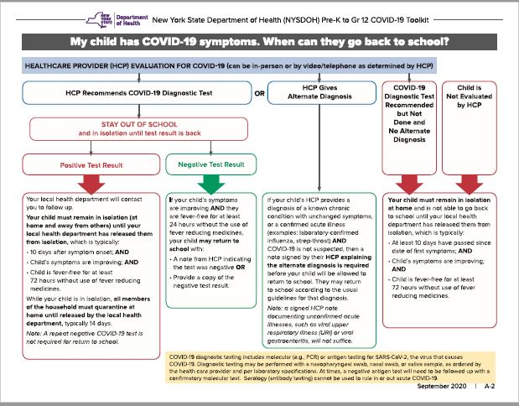

I'm assuming that the random COVID testing for students is only for students returning to the physical building. Is this correct?
Yes.

Why is there an opt-out for COVID testing? That has me concerned that there are positive students walking around and not being identified.
Currently, parents have a right to opt their child out of COVID testing. The District cannot exclude a student from in-person learning because a parent has not consented.

Will there be a nurse on site full time?
Yes.

Do you only have one thermal thermometer?
There are currently 2 thermal thermometers in the building. An additional one has been ordered.

Social Distancing Protocols
What will happen if students don’t follow social distancing protocols?
The 2020-21 BPS Code of Conduct will address instances where students violate social distancing protocols. Progressive discipline measures will be used. If a student continues to violate social distancing protocols, they will have to return to remote instruction.

Will the number of students in bathrooms during transition times be monitored? Also, will there be flexibility in the passing time if students need more due to lines in the bathrooms?
Yes, the number of students in bathrooms during transitions and class time will be monitored to stay within social distancing guidelines. There will be flexibility during pass time to address student needs.

Will the students change classes, or will they stay put and the teachers move?
For Phase 1, Seniors will change classes. This will be revisited as other grade levels are phased in.

Will the students be allowed extra time between classes since each stairway has one direction now?
Transition time is 4 minutes. While students are acclimated to the new traffic patterns, there will be flexibility.

Can students bring their own lunch?
Students may bring their own lunch if they would like.

Cleaning Protocols
Will classrooms be cleaned after each group of student leaves and before the next enters? Desks/surfaces cleaned?
All high-traffic areas and high touch surfaces will be cleaned before the start of the day, throughout the day and at the end of the day.

Transportation
Will the tripper buses still run?
Tripper buses will depend on number of students returning, they are not guaranteed.

When might there be an answer about the tripper buses?
Once we have an accurate number of returning students, the Transportation Department will let us know about tripper buses and specials.

How do high school students obtain NFTA bus passes?
The Transportation Department will coordinate NFTA bus pass distribution as in previous years. Students are usually allowed on buses for free during the first week until bus passes are delivered to the buildings. The Transportation Department will communicate specific information to families.

Will buses be cleaned between routes?
All high-touch surfaces will be sanitized throughout the day.

Will bus stops be at corners or at homes?
Bus stops are usually at corners.

The bus passes they have from last year will still be valid?
Students receive new bus passes every school year. Last year’s bus passes will not be valid.

What if an upper grade student has lost their bus pass from last year?
A 2020-21 School Year bus pass will be issued to all students eligible for NFTA transportation. If a student loses a bus pass throughout the year, they are to fill out a bus pass replacement form. It takes 7-10 business days to replace a lost/stolen bus pass.

What if all the busses are full at dismissal time and there are students who don't fit on the bus? What are they supposed to do?
At this point, we have not been guaranteed any specials at dismissal as those depend on the number of students using specific NFTA routes. If this were to be a problem, students would use the bus stop on Bailey Avenue, as in years past.

What is the capacity for Special Education busses?
Bus capacity varies depending on size. The Transportation Department will be making sure students remain socially distant on the bus.

Phase-In
When is the 156 Survey due for non-Seniors?
We are asking parents to submit the 156 Survey as soon as possible, by January 20th, if possible.

Will the survey link be sent out?
You may complete the survey at https://forms.office.com/Pages/ResponsePage.aspx?id=nNCgtVioaUS_aFWqCu5g2qgrThyy1tlBsT42Q4I92iRUQ1MzRlJHQVA1OEZRMzMzVFVUMTU1TkswSi4u

Is this a ten (10 ) week commitment?
Currently, the phase-in commitment is for Quarter 3, which ends April 23, 2021.

It looks like the opt-out form is only for parents to opt-out. Is there a form to fill out stating that the students will be returning to school?
We are asking all parents to complete the Olmsted 156 Phase-In Survey, using the link provided above.

Are you planning that returning seniors will be in the building five days/week?
Our phase-in plan for the first wave is for Seniors, 5 days a week

How many days a week for students in other grades?
Under the hybrid model, we will phase-in one group Monday and Tuesday and a different group Thursday and Friday.
How are in-person remote students determined? Does it vary based on the day?
It will be determined on the number of students returning. For the first phase, all efforts will be made to maintain students with their teacher. If multiple classes are needed, Administration will work on a rotation of students so that all students have equal access to their teacher.

Will you honor hybrid days for students who have siblings in other schools and are already attending school on specific days?
We will make every effort to honor hybrid days for students with siblings in other schools who are already attending school as part of a phase-in.

How do you have enough classrooms and teachers for all seniors if they are on site M-F but only have a density of 9/10 students per Classroom. Wouldn't you need about double the teachers?
Staffing and number of classrooms will depend on the number of students returning.

Can you still opt out?
Yes, you can opt out. If you have not filled out the opt survey, please go to www.buffaloschools.org/reopen

What will determine if a student is in-person or in-person remote?
Determination of in-person or in-person remote will be based on the room capacity per classroom and the number of students returning to in-person learning. When the number of students returning exceeds the capacity, Administration may relocate classrooms to larger spaces or use multiple spaces and work out a rotation of students to ensure all students have equal access to their assigned teacher.

Did you say students will keep the same teachers? Please explain further.
All efforts will be focused on keeping schedules and teacher assignments as is.

How can students have same teacher if some stay remote and some return to in-person learning?
Teachers will be teaching students in-person and virtually simultaneously.

Curriculum & Instruction
Teachers will teach the students in front of them and the remote students at the same time?
Teachers will be teaching students in-person and virtually simultaneously.

What will PE look like if a student has that class on one of their in-person days?
Physical Education classes will remain on virtual instruction.

I assume there will be no swim, correct?
There will be no in-person swim. Swim instruction will remain virtual.

When you mentioned music to remain remote, is that also general music class?
Yes. Music instruction will remain virtual.
Has there been any guidance from the district regarding related services (peech, occupational therapy, physical therapy)
We are waiting on further direction from the District on specific guidance for delivering services to students in-person and remote.

Students that will be attending school will they be required to go on days that are asynchronous?
Olmsted 156 does not have a schedule where days are all-asynchronous. In-person learning will continue to follow the synchronous/asynchronous schedule to stay on pace with remote learners.

Next Steps
What are the plans beyond Phase 1, seniors? How soon is the next phase and for what population of students?
The first phase is for Grade 12. Other phases and timelines will be determined by the District.

When are Grades 5, 6, 8 and 9 returning? When is special Ed being considered?
We will follow the timelines provided by the District for phasing in additional students. Determination of students for the next phase will occur using the same guidelines used for Phase 1: attendance, academic and referral data as well as student, parent, staff and administrative input. These will be discussed in future SBMT meetings, held monthly.

How did the 8th graders compare to the high school students regarding academic performance? shouldn’t they also be prioritized?
For the most part, all students performed about the same. The Parent Newsletter has specific data for all grade levels and subject areas. The biggest concern in choosing the Seniors was the upcoming transition to college and/or careers and the additional guidance and follow-through needed to make sure this is a seamless transition after being out of the building for almost a year.

Miscellaneous
Is there any word if school sports will happen this year?
NYS reinstated low risk Winter sports. BPS has not reinstated any sports as all efforts are focused on reopening our schools.

I have a 5 grader who has not been in the building before and is in 8:1:1 classroom. If I drive her, who will show her how to get to her classroom and which door would she enter?
All students will enter through the Main Entrance on Suffolk St. Multiple staff members will be supervising entrance and dismissal, directing students to their homerooms.

Is student parking still required to the streets or parking lot?
The parking lot is reserved for BPS employees. Students that are driving must park on the street as parking is limited.

